Out of the Cold Clothing Coordinator

I have been the Out of the Cold Clothing (OOTC) Coordinator for the past two years, beginning in October, 2011. Before this date I worked in the OOTC Program for two years serving hot meals. In the capacity of Coordinator, I been responsible for overseeing the weekly operations of the OOTC clothing department and have assisted in outreach for donations. In my leadership role I provide support and guidance to a team of five other volunteers. I utilize my very best teamwork skills in order to run a successful clothing department.

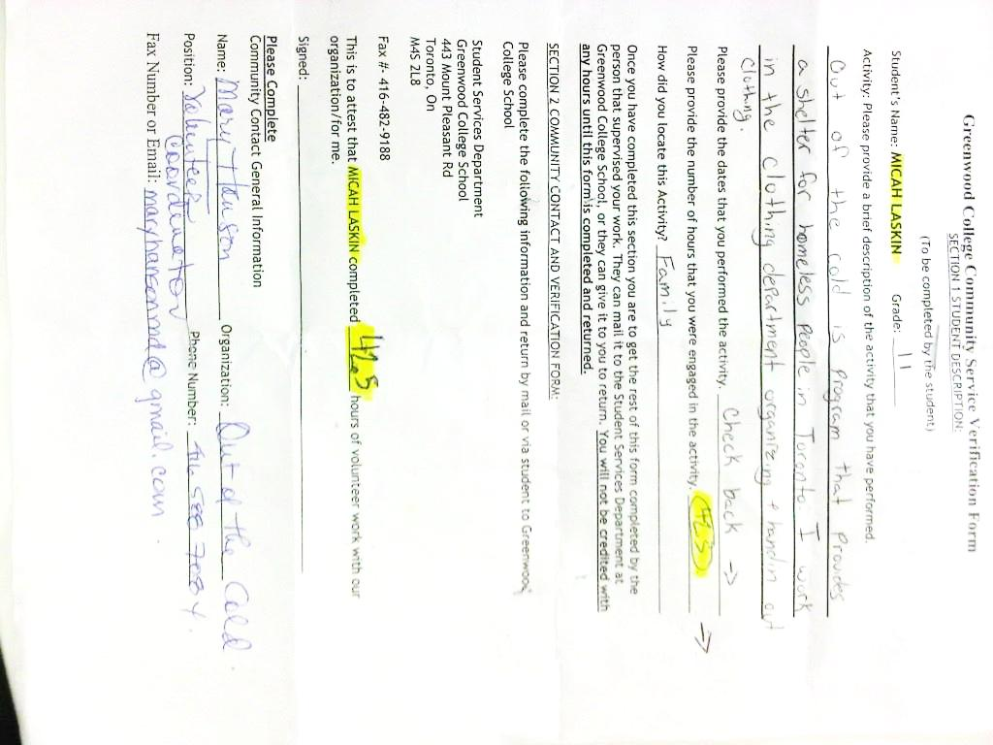
Proof of Completion:


Micah Laskin Mary Hanson (Volunteer Coordinator)

